***What is Node.js***

Why Node.js?

Node.js allows us to create backend using **JS**. Node.js is a superfast and allows to create fast running websites like ebay, twitter and Netflix etc. 

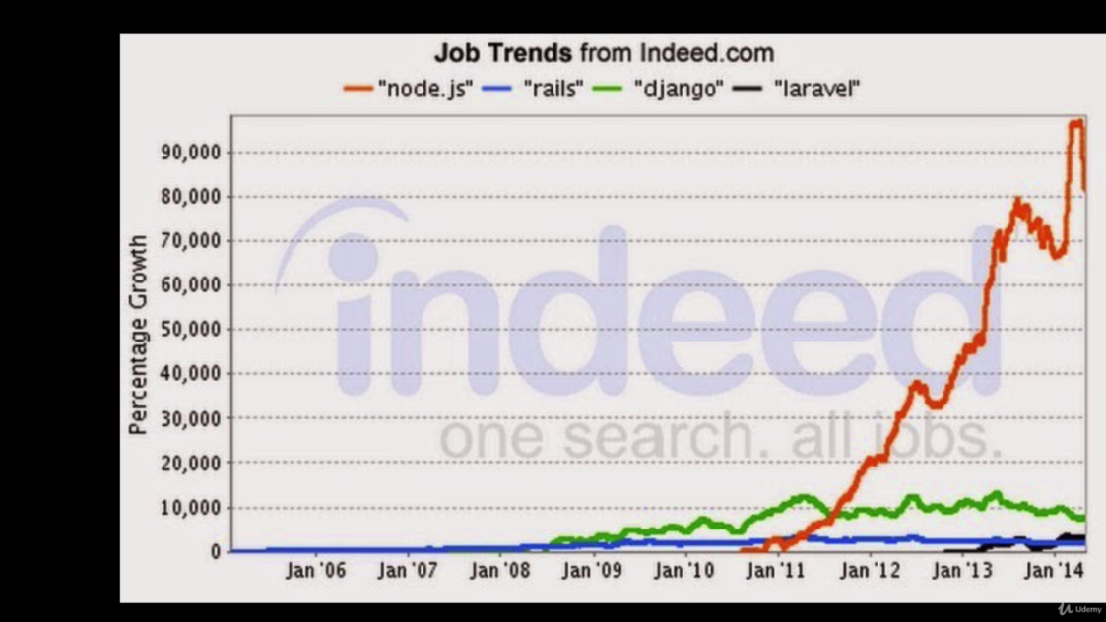

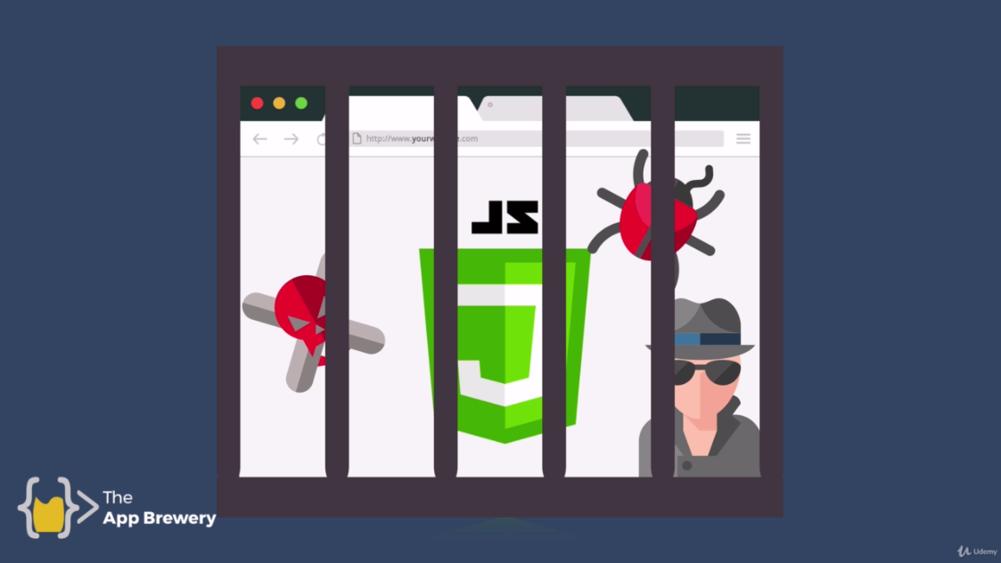

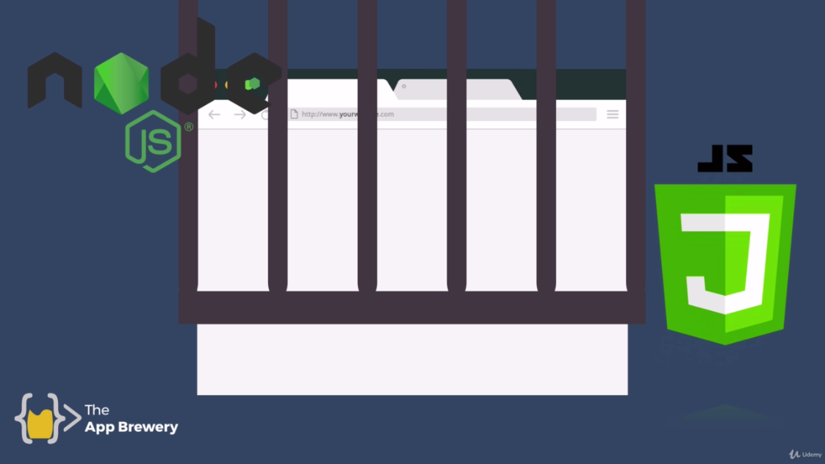



Node JS allows us to interact with the hardware directly. For example to create a desktop application like atom.

We can also use node JS to run JavaScript code on somebody else’s computer.

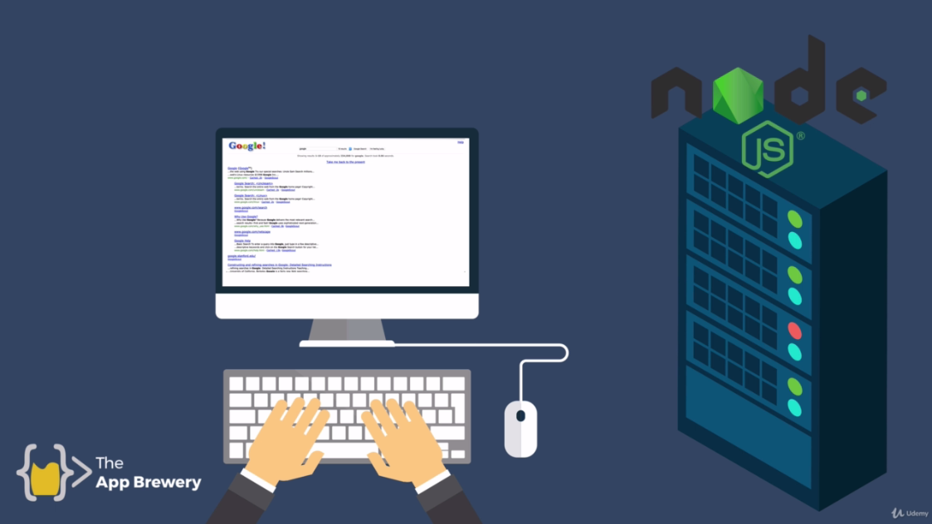

For example, when we make a query to browser, browser make request to google servers and on the server we can actually use JS code to execute the request and after that done we can response back to the client.